Stephenville Museum Photos

#27 John Tarleton Agricultural College football team – 1919 – TA000076
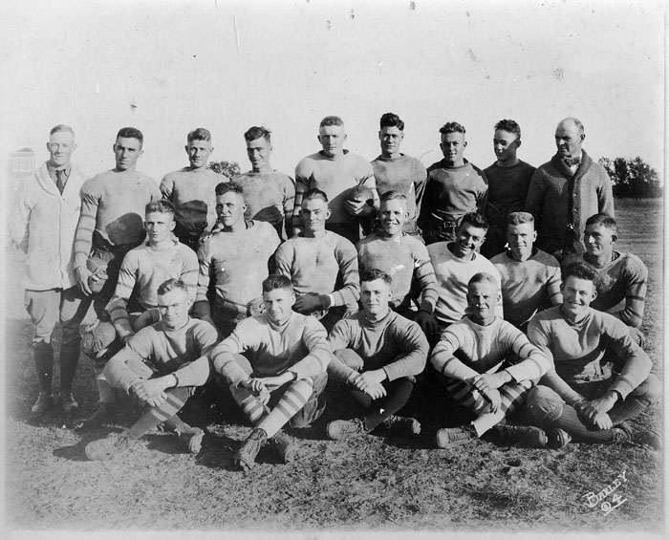

#28 John Tarleton Agricultural College girls basketball – 1917-1918 – TA000312
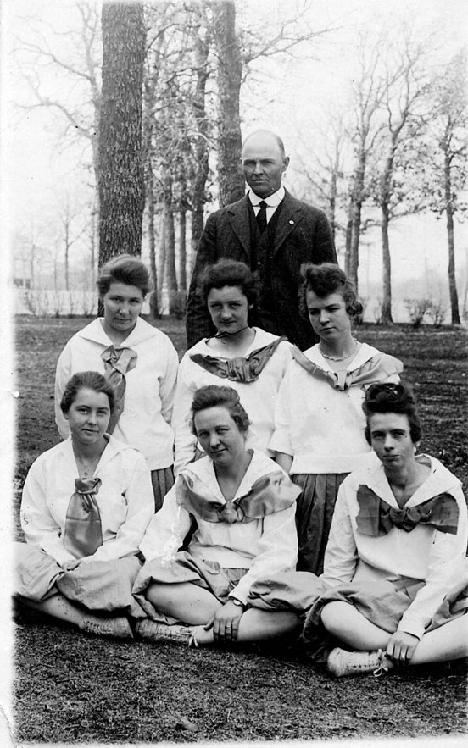

#70 Bird’s Eye View of Stephenville, Texas – SM000167

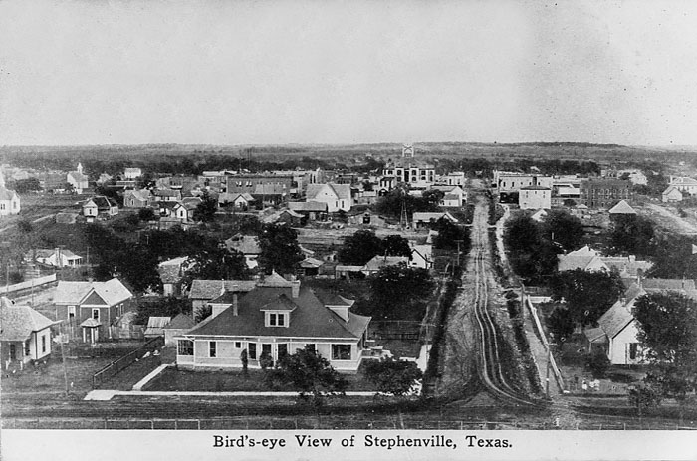

#71 Erath County courthouse – SM000760
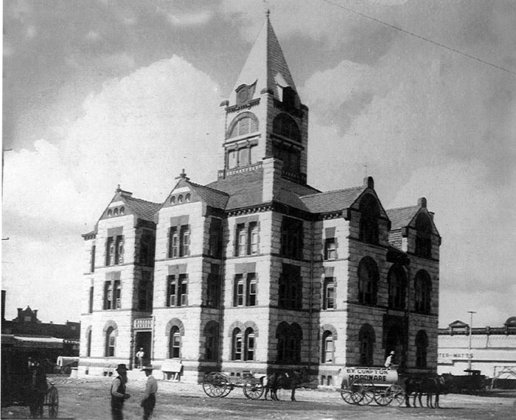

#72 Erath County courthouse – SM000756

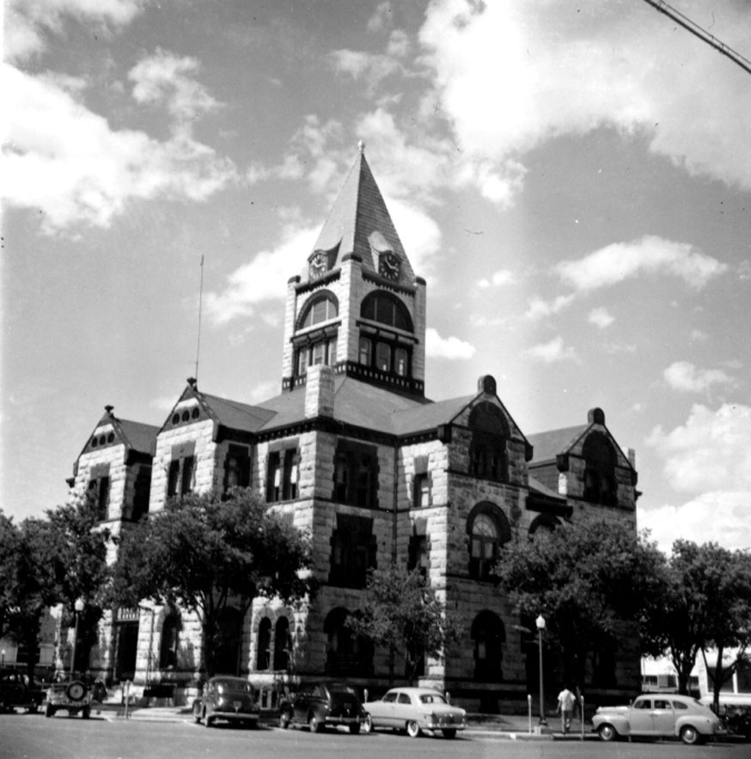

#76 East side of town square – SM000753
