Troop 39 of Stephenville Texas
Troop 39 has been apart of Stephenville Texas and has made an impact on the community and Comanche Trail Council for more than 66 years. This troop is not only a place for a kid to leam, but also grow and live by all parts of the scout oath, law, slogan, and motto. These four points are not only for kids and young men, but at the same time show the leaders and parents of the troop how to live there lives and be good role models.
Troop 39 was started in the late 30's. Since the beginning of Troop 39 there have been 23 Scout Masters. The most dedicated and honorable Scout Master was Donald F. Smith. He served from (1967-1987) a total of 20 years the longest of any man that served in his position. The present day Scout House is named in honor of Donald F. Smith for his dedicated service to the Boys Scouts of America, Troop 39, and Stephenville, Texas (Charlie Fulton).
Records in the Comanche Trail Council of Boy Scouts, Brownwood, show that in July 1944 Troop 39 and Troop 41, both sponsored by the Lions Club, met for the first time in "Scout Hut, City Park." Funds for this building, erected at a total cost of $1250. that had been raised by Winston Welch and J.W. Heaton, Canvassing the city, business by business. The building was east of where the first ball diamond was, on the site of a concession stand. Then came the floods, and water was waist deep in the homes along East Washington, where the museum is now located. The scout house was moved to higher ground, "on the banks of the Bosque in the eastern section of the city."
A noon barbecue was staged on these grounds in November 1949. Frank Mooseberg, scoutmaster for Troop 39, displayed plans for a structure to serve as the main building for scouting. It would "utilize brick walls of a former cattle barn," and Mooseberg, who was in charge of Tarleton’s dining facilities, suggested that exterior walls could be made of rock collected from the five acres surrounding the Scout headquarters at the time Stephenville was home of three Scout Troops and one Explorer Post.
Some time later, and the date remains as elusive, the old hut was torn down, and a log cabin moved to the site. These logs from the southeastern part of the county were moved to school property on which Future Farmers of America students of the high school once cooped and penned their project animals and poultry.
Dr. Ed Camer, who was a Scout in the 60's, recalls that Scoutmaster Arlon "Chink" Weems used to tell members of his troop that they were meeting in the Snow cabin. And Larry Don Smith, who later became a Scoutmaster, remembers his father, Scoutmaster Donald F. Smith, taking members of Troop 39 to camp on the site of the Snow place, where there were some stone foundations and an old comcrib still standing.
As the story was told, Mr. P.M. Snow, a cedar post cutter, came to the county in 1924 in an old wagon pulled by two horses. In the bed of the wagon were a double blade ax, a couple of hounds, and some furniture. He rented a place in the Indian Creek community eight miles southeast of Stephenville. A widow, Maggie Poston; her son, Bemie Connelly; and her mother, Mrs. S.A. Olds, came to the community to pick cotton in the fall of 1925. Snow became interested in the widow, and the two exchanged wedding vows in Stephenville Oct. 6,1925. He giving his age as 66 and she as 51. The son and mother moved into the home with the newlyweds. On Nov. 27, 1925, Snow became irate because his wife had not chased a cow from the front yard. He beat her to death with a slat from the paling fence. He then slipped behind Mrs. Olds and almost severed her head with his ax. He placed the bodies under the floor of the cabin. Snow rode to Stephenville, where he told Bemie that his mother was ill. As soon as they rode into the hoe place. Snow killed the boy. Snow changed teams and drove toward Cedar Point Mountain. About midnight he chopped the boy's head from the body and deposited it in a tote sack, which he tossed into some bushes. Unable to find a well into which to place the body, he put it into an abandoned cellar. Back in the cabin, he washed the walls and floor with lye water and built a roaring fire in the fireplace. Bit by bit, he threw the women's bodies into the flames.
Two young boys, Elvis Riggs and Ben Aycock, were hunting when their dog approached the cedar and began baying. When they discovered the tote sack, they notified the Erath County Sheriff. Years passed. Paul Cunyus was dean of Tarleton and a scout official when the cabin was offered to the Stephenville Scouts and moved to grounds overlooking the low-water bridge over Long Street. More time elapsed and the wall on each side of the fireplace was destroyed by fire. Scouts decided to push the logs from the foundation to the riverbank.
Dr. Robert Walker, professor of English at Tarleton, was dismayed at the fate of the logs and appealed to Scout authorities. "If you want them, take them," officials said, "Take the entire cabin." Walker, with the aid of two Tarleton students, scraped the logs, numbered them, and moved them to the Walker’s garage for storing. After two years, Gretchen Walker convinced her husband the family needed more storage space.
Believing he had a prize in the logs. Walker offered them to Stephenville Museum. He received little enthusiasm from the head of the museum, but she consulted the Texas Historical Commission. As usual, authorities in Austin offered little help but tons of advice, suggesting that the logs be painted white before being used in any kind of construction. His offer declined. Walker then stored them in Dan Young's barn and later they were moved to museum grounds. "I figured they'll rot there," Walker recalls. Such was not the case. A one-room cabin belonging to Billy Jones near Paluxy was moved to the museum grounds, and museum authorities saw the possibility of using it as the sleeping den and making the Walker logs into a kitchen pen of a dogtrot cabin. A medallion identifies the dogtrot cabin as composed of the Jones cabin and of the cabin donated by Dr. Walker, which once served as the Boy Scout house on East Long Street.
Stephenville Historical Museum
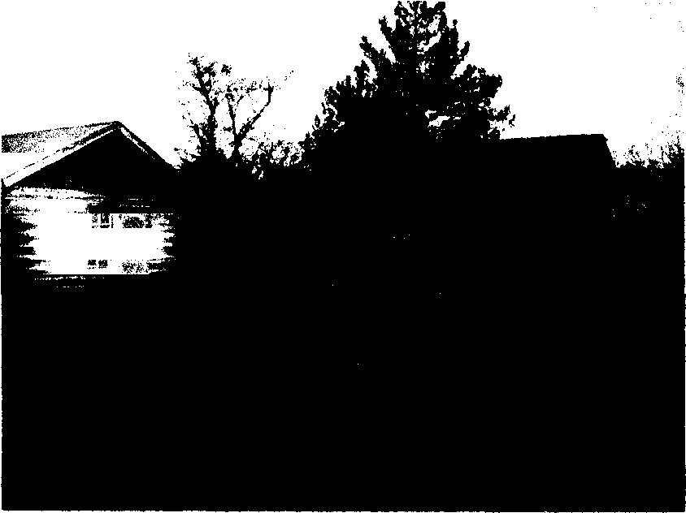

The house which replaced the log cabin as headquarters for Troop 39 was described recently by David Picha. The current meeting place, he said, is "an old wood frame house which is leaking, the shingles can't be replaced, and the rafters are basically rotten." "The building has cracks in it, and this is a problem we should have addressed a long time ago." At this time they were faced with raising $35,000. for the new scout center (Larry Smith/Stephenville Empire-Tribune 8/19/97).
The Lions Club, which sponsors Troop 39, raised the $35,000. for the construction of the new Scout Center with the help of the Stephenville Community. On January 30,1998 the Scout Center was dedicated and ready for occupancy by Troop 39. In 2001,1 assisted my father Kell Jones the Assistant Scout Master with the installation of the first ever Heating & Air Conditioning System in the Scout Center which was one of his ticket items from a Wood Badge course he attended at Camp Billy Gibbons (Larry Smith/Kell Jones).

Donald F. Smith Scouting Center.

