The history of theatre productions at Stephenville High School has had a slow, wavering history. The theatre system of today is far different than that of its predecessors. Over the past 8 decades, the school has gone through 3 different auditoriums. The first was in 1921, when the three-story building was built. It came complete with stage and balcony. The original purpose for this auditorium was mainly for school assemblies and pep rallies, seeing as how there was not yet a constructed gym. It was in 1938 that there was a first documented indication of a theatrical club. However, records between the years 1923 and 1937 are scarce; most likely do to the effects of the depression. The original collection of actors was known as "The Dramatic Club". The purpose of this club was to give its members an opportunity to learn and to put into practice the fundamentals of dramatics, and to study the lives of famous dramatics, actors, actresses, and lecturers. The club's director and sponsor was Virginia Schell. The original officers were as follows:
President: Ida Lee Foster
Vice President: Grady Daniel
Secretary: Betty Ruth Rigging

Treasurer: Mary Jane Andersen

The club flourished for many years under a very different organization than what we are accustomed to today. Back then, plays were open to the entire school, and at prescheduled dates in the year, each class (e.g. Junior, Senior, etc.) would produce and present its own play. Those participating in a play were then offered to join the Dramatic club and join in its activities.
However, with time, things break down; and in 1960, the original building was renovated and a new building was created along with a brand new auditorium. The old auditorium base floor was converted into a new library and the balcony that was once so illustrious balcony was closed until the buildings destruction, after years of occasionally being used as storage space. However, the new superlative auditorium seated 800 even though the school had only 500 students. The idea portrayed at this time and the underlining them of the year's yearbook was
hope for the future. The school was optimistic and knew that its student enrollment would continue to expand over the years to come. The first presentation play in the new auditorium took place in December and was, as usual, open to all-school. It was called "Our Hearts Were Young and Gay" 'so ably directed by Mrs. June Shannon, has been acclaimed one of the best productions of the year.' The theme of renewal in the play made it seem perfectly fitting for the auditoriums 'christening'.
Yet, alas, another decade went by and another school was built in 1976. This present day high school was complete with an even larger seating capacity and integrated with the school, unlike the previous one, which was segregated from the actual school.
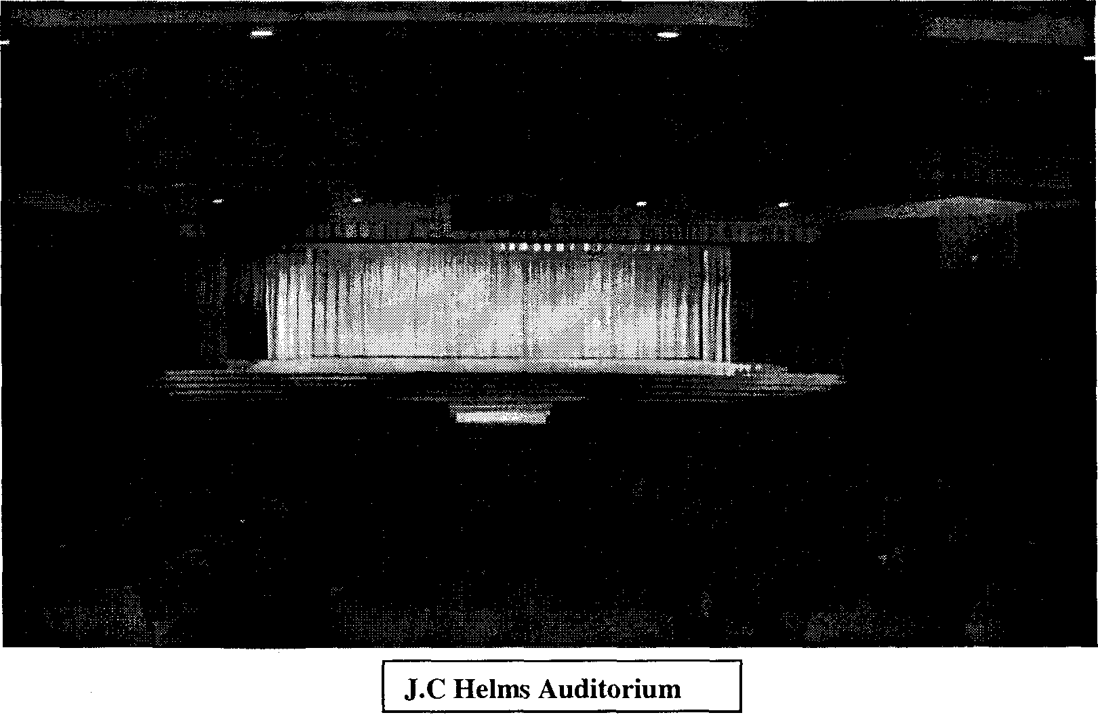
However, the coordination of a true thespians society was still not achieved. No plays were produced, and the original Dramatic Club had completely dissolved away. It wasn't until 1989, when Mrs. Linda Brown became the new drama teacher. In the early ninety's she was the one that brought the town's attention to theatre. Nobody would give the struggling thespians funding, because, it had never truly thrived before. Working solely on fundraising and self support Brown was able to increase the quality of the stage by purchasing lights, washers, costumes, light boards and also got students interested in theatre itself. While casting parts for the 1991 production of Our Town, Brown expected maybe ten people at the most. Instead, she got 61. She called open casting to all people in the school including football players, drill team dancers, choir members, honor students, and more. Eventually, she entered the school into the International Thespian Society, which allowed students to join in a group of people spanning all over America and in parts of other countries. The society allowed students to
receive benefits such as scholarships and theatrical unity. However, in order to be included in this prestigious organization, certain qualifications had to be met, such as participating in a number of plays and earning a high enough rating on a point system. This system is still in full swing to this day. During her reign as Drama teacher, Brown directed plays such as It Takes a Wizard, Up the Down Staircase, Our Town, Scenes from Medea, Ducktails and Babbysox, A Midsummer's Night Dream, Dirty Work Afoot, The Tamins of the Shrew, and much, much more. She created the tradition of Presentation Play, which entertained students and also served as an institution for the distributing of “Best” awards. She also started the school in participating in local UIL (University Interscholastic League) One-Act Play competitions, and won several awards, and advancements. Finally in 1997, Linda Brown gave her final bow, and left her position as Drama teacher. After her would come Emily McLemore, Alice Goins and the present theatre teacher, and former student of Brown, Mindy Pope. While she has only been here for two years, it is evident that she is here to stay. She has already produced Aesop's Fables. Dirty Work Afoot, Act Three, Scene Five, Woolfie, Murder's in the Heir, and most recently. Scenes from Opal. Presently Theatre Productions are an exclusive organization and in order to be in a play, one must be in the class. In order to be involved in the class, one must show a level of determination. This ensures that no miscreants will be in a play and ruin it for everybody. Currently, there are so many students involved in Thespians Society that the original charter is completely filled and there are more on the way in May.
Theatre Productions at SHS has grown beyond its believed potential, and there is currently no sign of it slowing down. With the aspiration of dozens of talented actors and actresses, there is no limit to the future of theatre. My hope is that with each new generation in this new millennium, theatre will get better, brighter, and even more talented. This school has been through 3 auditoriums so far; it is very likely that yet another will be built. And to the future actors to display their craft on that stage, I say, "Break a leg."


