

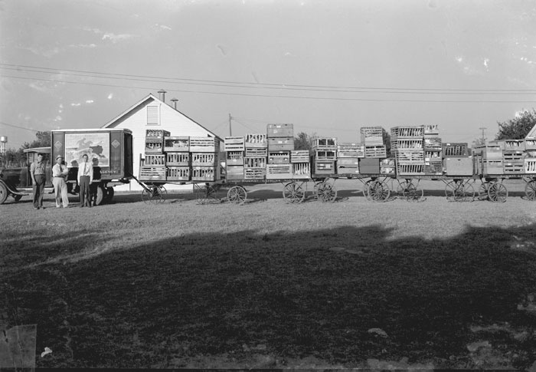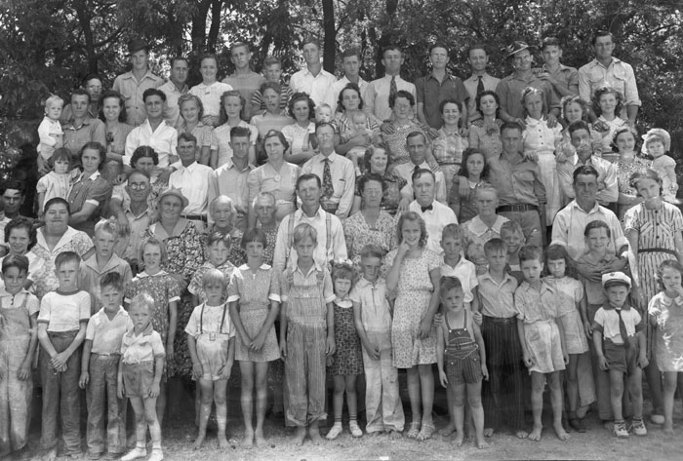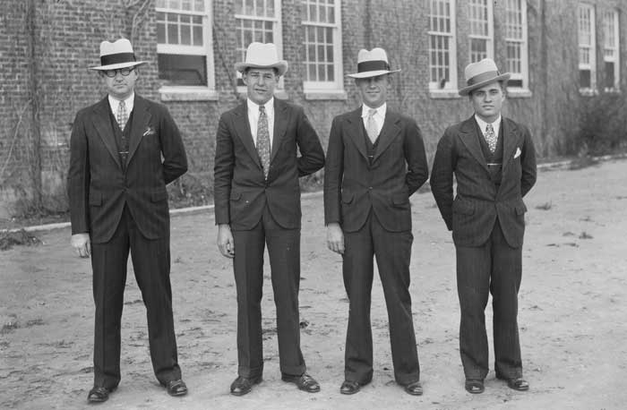**Baxley Collection**

Text Text Text Text Text Text Text Text Text Text Text Text Text Text Text Text Text Text Text Text Text.

Text Text Text Text Text Text Text Text Text Text Text Text Text Text Text Text Text Text Text Text Text.

Text Text Text Text Text Text Text Text Text Text Text Text Text Text Text Text Text Text Text Text Text.

Text Text Text Text Text Text Text Text Text Text Text Text Text Text Text Text Text Text Text Text Text.

Text Text Text Text Text Text Text Text Text Text Text Text Text Text Text Text Text Text Text Text Text.