

**Ed & Geraldine Sullivan Collection**

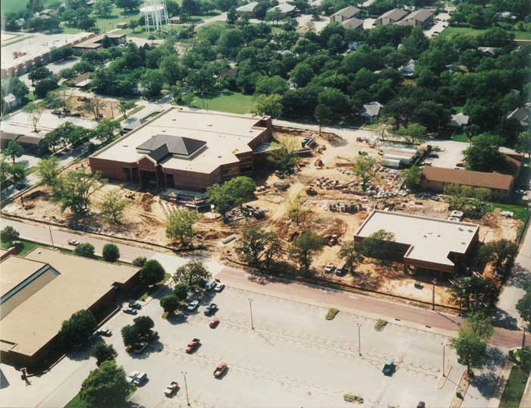



Text Text Text Text Text Text Text Text Text Text Text Text Text Text Text Text Text Text Text Text Text.

Text Text Text Text Text Text Text Text Text Text Text Text Text Text Text Text Text Text Text Text Text.

Text Text Text Text Text Text Text Text Text Text Text Text Text Text Text Text Text Text Text Text Text.

Text Text Text Text Text Text Text Text Text Text Text Text Text Text Text Text Text Text Text Text Text.

Text Text Text Text Text Text Text Text Text Text Text Text Text Text Text Text Text Text Text Text Text.