Announcing the ***Friends of the Dick Smith Library***

***“*Dinner in the Stacks”**

*The Accidental Band*

*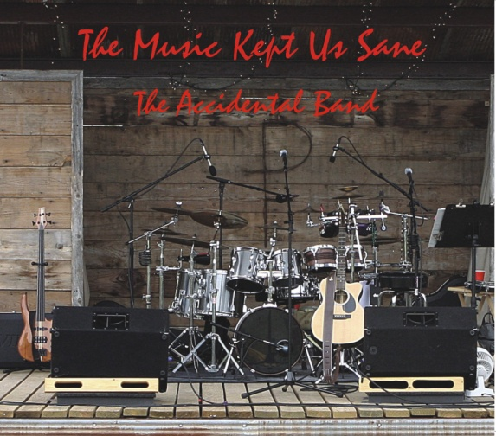 with*

*Craig Clifford, Jim & Nancy Easterling*

*presenting*

*The Music Kept Us Sane !*

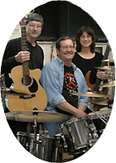

Saturday, April 2, 2011

Appetizers 6:30 P.M.

Dinner 7:00 P.M.

Tarleton’s own Craig Clifford and Jim and Nancy Easterling will be entertaining us with enjoyable music for this spring’s Friends of the Library Dinner in the Stacks! The Accidental Band’s latest album, *The Music Kept Us Sane*, circles around a folk and folk-rock core, with hints of blues and classic country. Lead singer and guitarist Craig Clifford, plays a finger-picking folk style on acoustic guitar. Jim Easterling plays drums and sings harmony. Nancy Easterling plays a fretless bass that complements the sound of the acoustic guitar. The unique sound created by the three band members brings together a combination of musical styles from ballads to traditional country and from a straight-up drum beat to bongos!

Come join us for an evening of fun and fellowship!

**Members $15.00**

**Non-members $17.50**

**Make your reservations now!**

**254/968-9871 or 254/968-9474**

**Business Sponsors:** **Dr. Kelly & Tawnya Doggett, First Financial Bank, NA, Suzanne & Taber Meyers, Saint Gobain Abrasives, Inc.**

**Business Patrons:** J. Brad & Nancy Gage Allen, Bluff Dale Vineyards, Scott’s Flowers on the Square, Town & Country Bank

**Business Friends:** Alisa Terrell Starbird, P.C., Community Nursing & Rehabilitation Center, Cross Timbers Family Dentistry, David Kincannon Insurance, David Stanphill, DDS, DeLeon High School, Drs. F. Dominic & C. Lisette Dottavio, FMC Technologies, Stephen E. Fambrough, Mayfield Paper Co., Moore Eye Center, Dr. Gary & Beverly Peer, Lisa Pence, Joe & Pam Sawyer, Stephenville City Electric, Stephenville Funeral Home, Dr. Frank & Kathy Terrell