Announcing the ***Friends of the Dick Smith Library***

***“*Dinner in the Stacks”**

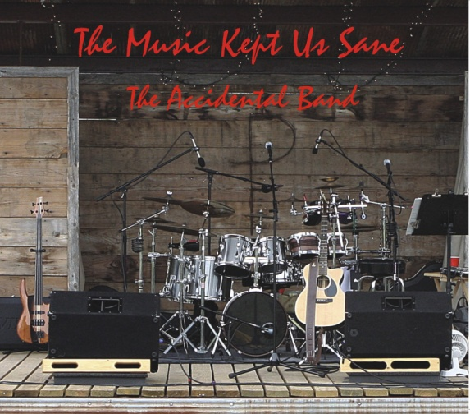Featuring…*.*

*The Accidental Band*

*with*

*Craig Clifford, Jim & Nancy Easterling*

*and*

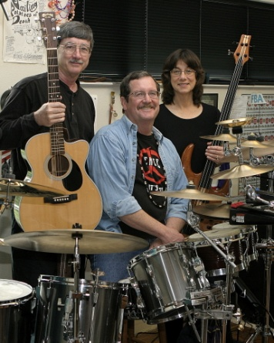

*The Music Kept Us Sane !*

Saturday, April 2, 2011

Appetizers 6:30 P.M.

Dinner 7:00 P.M.

Come join us for an evening of fun and fellowship!

**Members $15.00**

**Non-members $17.50**

**Make your reservations now!**

**254/968-9871 or 254/968-9474**

**Business Sponsors:** **Dr. Kelly & Tawnya Doggett, First Financial Bank, NA, Suzanne & Taber Meyers, Saint Gobain Abrasives, Inc.**

**Business Patrons:** J. Brad & Nancy Gage Allen, Bluff Dale Vineyards, Scott’s Flowers on the Square, Town & Country Bank

**Business Friends:** Alisa Terrell Starbird, P.C., Community Nursing & Rehabilitation Center, David Kincannon Insurance, David Stanphill, DDS, DeLeon High School, Drs. F. Dominic & C. Lisette Dottavio, FMC Technologies, Gifford TV & Electronics, Mayfield Paper Co., Moore Eye Center, Dr. Gary & Beverly Peer, Lisa Pence, Joe & Pam Sawyer, Stephenville City Electric, Stephenville Funeral Home, Dr. Frank & Kathy Terrell