

**Ruth Payne Grantham Collection**

Text Text Text Text Text Text Text Text Text Text Text Text Text Text Text Text Text Text Text Text Text.

Text Text Text Text Text Text Text Text Text Text Text Text Text Text Text Text Text Text Text Text Text.

Text Text Text Text Text Text Text Text Text Text Text Text Text Text Text Text Text Text Text Text Text.

Text Text Text Text Text Text Text Text Text Text Text Text Text Text Text Text Text Text Text Text Text.

Text Text Text Text Text Text Text Text Text Text Text Text Text Text Text Text Text Text Text Text Text.

Text Text Text Text Text Text Text Text Text Text Text Text Text Text Text Text Text Text Text Text Text.

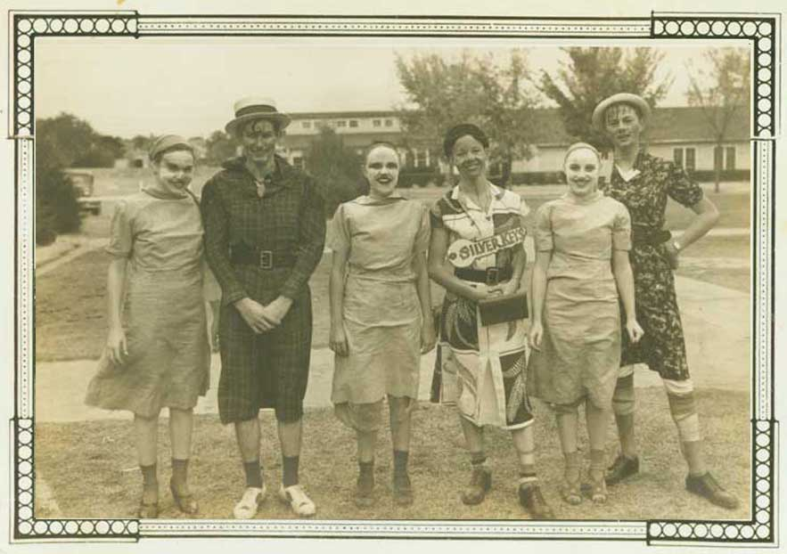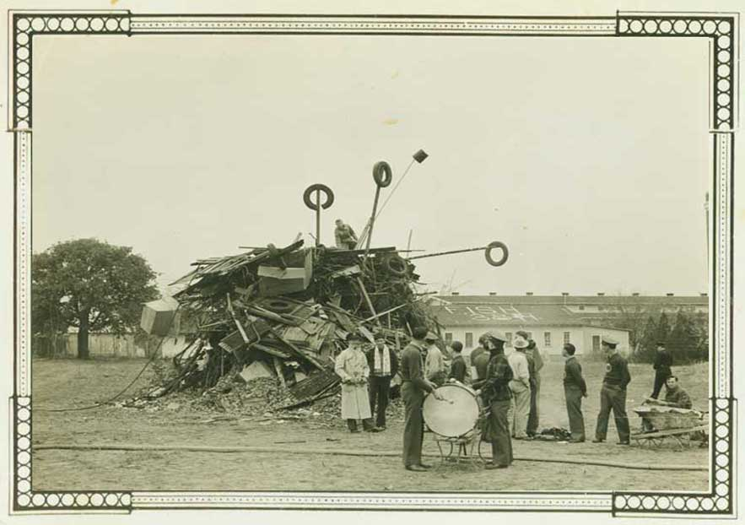

Text Text Text Text Text Text Text Text Text Text Text Text Text Text Text Text Text Text Text Text Text.

Text Text Text Text Text Text Text Text Text Text Text Text Text Text Text Text Text Text Text Text Text.

Text Text Text Text Text Text Text Text Text Text Text Text Text Text Text Text Text Text Text Text Text.