

**Stephenville Museum Collection**

Text Text Text Text Text Text Text Text Text Text Text Text Text Text Text Text Text Text Text Text Text.

Text Text Text Text Text Text Text Text Text Text Text Text Text Text Text Text Text Text Text Text Text.

Text Text Text Text Text Text Text Text Text Text Text Text Text Text Text Text Text Text Text Text Text.

Text Text Text Text Text Text Text Text Text Text Text Text Text Text Text Text Text Text Text Text Text.

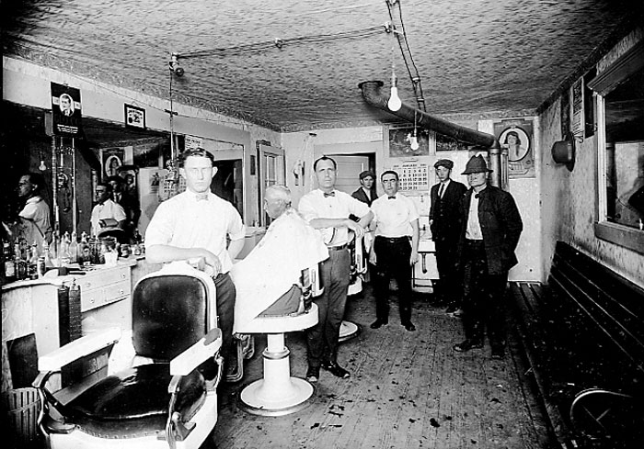

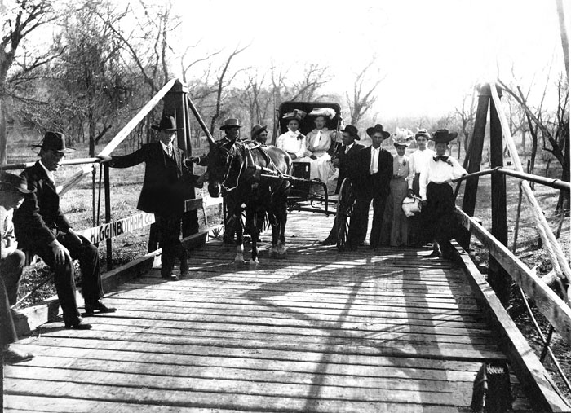

Text Text Text Text Text Text Text Text Text Text Text Text Text Text Text Text Text Text Text Text Text.

Text Text Text Text Text Text Text Text Text Text Text Text Text Text Text Text Text Text Text Text Text.

Text Text Text Text Text Text Text Text Text Text Text Text Text Text Text Text Text Text Text Text Text.

Text Text Text Text Text Text Text Text Text Text Text Text Text Text Text Text Text Text Text Text Text.

Text Text Text Text Text Text Text Text Text Text Text Text Text Text Text Text Text Text Text Text Text.

Text Text Text Text Text Text Text Text Text Text Text Text Text Text Text Text Text Text Text Text Text.