Thurber Collection By Frank Chamberlain
The Thurber Collection is a compilation of photographs assembled from a variety of sources including the Dick Smith Library at Tarleton and the Stephenville Museum. These photos document the story of one of the most unique Texas towns for the past century.
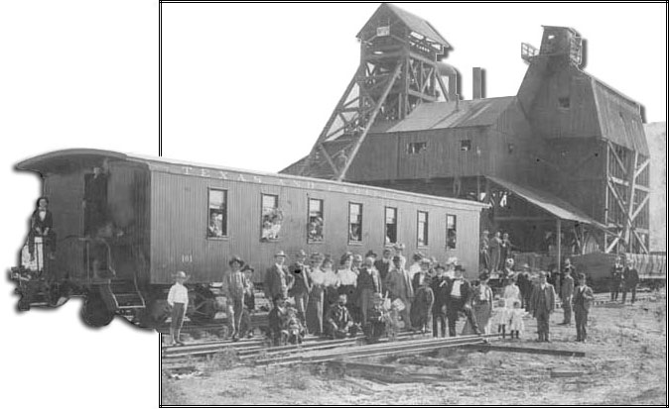

Learn more: http://www.tarleton.edu/~crosstimbersimages/

