Charles Goodnight

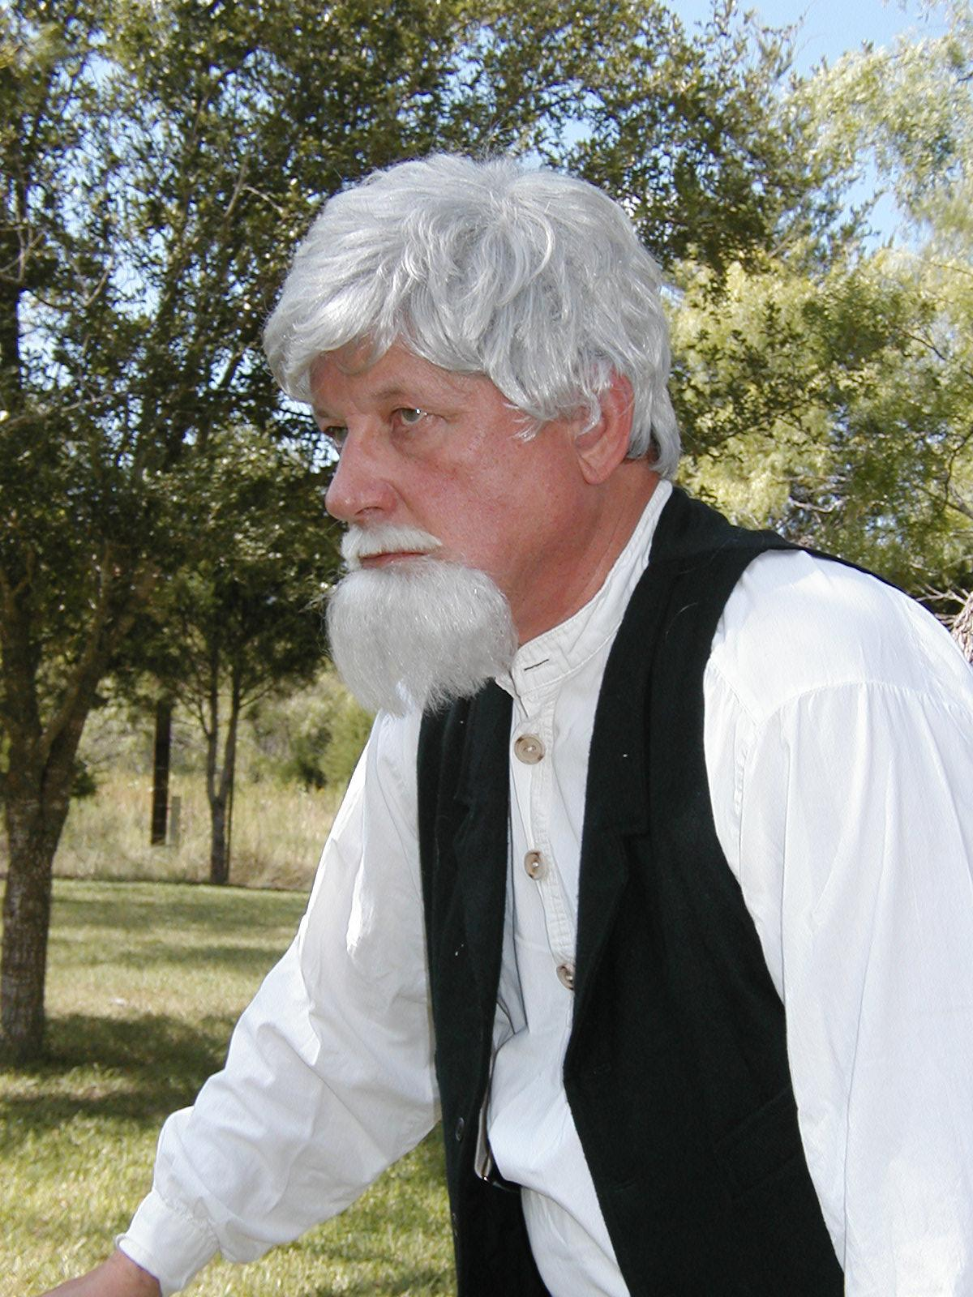

Portrayed by Bob Heinonen

